Gross Error (Human Error)
# Source: AI Source: Provided by: [Data Path: Persons Table -> ID Column: 1, Name_En Column: Motasem Essam] -> From: [ChatGPT] on [7/17/2026]
Gross Error, also known as Human Error, is a type of measurement error that results from mistakes or blunders made by the person performing, recording, calculating, or interpreting a measurement. Unlike systematic and random errors, gross errors are avoidable because they arise from incorrect human actions rather than limitations of the measurement system.
Gross errors can produce large deviations from the true value and often lead to invalid or unusable measurement results.

Definition
# Source: AI Source: Provided by: [Data Path: Persons Table -> ID Column: 1, Name_En Column: Motasem Essam] -> From: [ChatGPT] on [7/17/2026]
Gross Error (Human Error) is a measurement error caused by mistakes made by the observer or operator during the measurement, recording, calculation, or interpretation process.

Purpose of Studying Gross Errors
# Source: AI Source: Provided by: [Data Path: Persons Table -> ID Column: 1, Name_En Column: Motasem Essam] -> From: [ChatGPT] on [7/17/2026]
Understanding gross errors helps to:
- Improve measurement reliability.
- Reduce human mistakes.
- Enhance laboratory and workplace safety.
- Improve quality control.
- Develop better measurement procedures.
- Train operators effectively.

Characteristics
# Source: AI Source: Provided by: [Data Path: Persons Table -> ID Column: 1, Name_En Column: Motasem Essam] -> From: [ChatGPT] on [7/17/2026]
Gross errors:
- Are caused by human mistakes.
- Are generally large compared with random errors.
- Are avoidable.
- Occur irregularly.
- May affect both accuracy and precision.
- Usually make measurements obviously incorrect.

Examples
# Source: AI Source: Provided by: [Data Path: Persons Table -> ID Column: 1, Name_En Column: Motasem Essam] -> From: [ChatGPT] on [7/17/2026]
Examples of gross errors include:
- Reading the wrong scale on an instrument.
- Recording 52.3 instead of 25.3.
- Using the wrong unit (cm instead of mm).
- Forgetting to zero a measuring instrument.
- Misplacing the decimal point.
- Using the wrong formula in a calculation.
- Measuring the wrong object.
- Entering incorrect data into a computer.

Causes of Gross Errors
# Source: AI Source: Provided by: [Data Path: Persons Table -> ID Column: 1, Name_En Column: Motasem Essam] -> From: [ChatGPT] on [7/17/2026]
Gross errors commonly result from:
Reading Errors
- Misreading the instrument scale.
- Reading the wrong graduation.
- Ignoring the correct meniscus level.

Recording Errors
- Writing incorrect numbers.
- Transposing digits.
- Omitting measurements.
- Using incorrect units.

Calculation Errors
- Arithmetic mistakes.
- Incorrect formulas.
- Incorrect unit conversions.
- Calculator misuse.

Operational Errors
- Using the wrong measuring instrument.
- Incorrect instrument setup.
- Improper measurement technique.
- Failure to follow procedures.

Judgment Errors
# Source: AI Source: Provided by: [Data Path: Persons Table -> ID Column: 1, Name_En Column: Motasem Essam] -> From: [ChatGPT] on [7/17/2026]
- Incorrect interpretation of results.
- Wrong assumptions.
- Carelessness.
- Lack of attention.

Identifying Gross Errors
# Source: AI Source: Provided by: [Data Path: Persons Table -> ID Column: 1, Name_En Column: Motasem Essam] -> From: [ChatGPT] on [7/17/2026]
Gross errors can often be identified by:
- Repeating measurements.
- Comparing results with expected values.
- Reviewing recorded data.
- Independent verification by another operator.
- Statistical analysis to detect obvious outliers.

Preventing Gross Errors
# Source: AI Source: Provided by: [Data Path: Persons Table -> ID Column: 1, Name_En Column: Motasem Essam] -> From: [ChatGPT] on [7/17/2026]
Gross errors can be minimized by:
- Following standardized procedures.
- Proper operator training.
- Double-checking measurements.
- Verifying calculations.
- Reviewing recorded data.
- Using automated data collection when appropriate.
- Maintaining concentration during measurements.
- Performing independent inspections.

Applications
# Source: AI Source: Provided by: [Data Path: Persons Table -> ID Column: 1, Name_En Column: Motasem Essam] -> From: [ChatGPT] on [7/17/2026]
Preventing gross errors is essential in:
- Engineering
- Manufacturing
- Medicine
- Pharmacy
- Laboratory work
- Surveying
- Scientific research
- Aviation
- Construction
- Quality assurance

Everyday Examples
# Source: AI Source: Provided by: [Data Path: Persons Table -> ID Column: 1, Name_En Column: Motasem Essam] -> From: [ChatGPT] on [7/17/2026]
Examples include:
- Reading a thermometer incorrectly.
- Entering the wrong dosage in medical records.
- Measuring a room with the wrong unit.
- Recording the wrong weight on a shipping label.
- Pressing the wrong button on a digital instrument.

Common Mistakes
# Source: AI Source: Provided by: [Data Path: Persons Table -> ID Column: 1, Name_En Column: Motasem Essam] -> From: [ChatGPT] on [7/17/2026]
Common gross errors include:
- Skipping measurement steps.
- Recording values incorrectly.
- Misreading scales.
- Using damaged instruments.
- Ignoring calibration instructions.
- Mixing measurement units.

Gross Error vs. Systematic Error
# Source: AI Source: Provided by: [Data Path: Persons Table -> ID Column: 1, Name_En Column: Motasem Essam] -> From: [ChatGPT] on [7/17/2026]
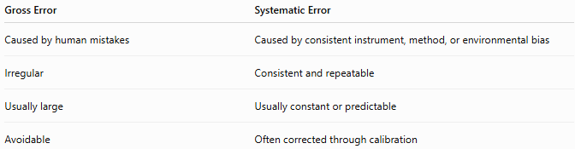
Gross Error | Systematic Error
Caused by human mistakes | Caused by consistent instrument, method, or environmental bias
Irregular | Consistent and repeatable
Usually large | Usually constant or predictable
Avoidable | Often corrected through calibration

Gross Error vs. Random Error
# Source: AI Source: Provided by: [Data Path: Persons Table -> ID Column: 1, Name_En Column: Motasem Essam] -> From: [ChatGPT] on [7/17/2026]
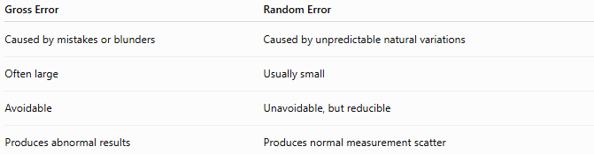
Gross Error | Random Error
Caused by mistakes or blunders | Caused by unpredictable natural variations
Often large | Usually small
Avoidable | Unavoidable, but reducible
Produces abnormal results | Produces normal measurement scatter

Gross Error vs. Measurement Uncertainty
# Source: AI Source: Provided by: [Data Path: Persons Table -> ID Column: 1, Name_En Column: Motasem Essam] -> From: [ChatGPT] on [7/17/2026]
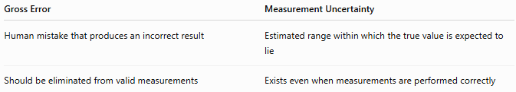
Gross Error | Measurement Uncertainty
Human mistake that produces an incorrect result | Estimated range within which the true value is expected to lie
Should be eliminated from valid measurements | Exists even when measurements are performed correctly

Importance
# Source: AI Source: Provided by: [Data Path: Persons Table -> ID Column: 1, Name_En Column: Motasem Essam] -> From: [ChatGPT] on [7/17/2026]
Understanding gross errors:
- Improves measurement reliability.
- Reduces costly mistakes.
- Improves product quality.
- Enhances laboratory safety.
- Supports scientific integrity.
- Ensures compliance with quality standards.

Key Points
# Source: AI Source: Provided by: [Data Path: Persons Table -> ID Column: 1, Name_En Column: Motasem Essam] -> From: [ChatGPT] on [7/17/2026]
- Gross errors are human mistakes made during measurement or data handling.
- They are avoidable through proper training and procedures.
- Gross errors can affect both accuracy and precision.
- Common causes include incorrect reading, recording, calculation, and instrument use.
- Verification, repetition, and careful review are effective ways to detect and prevent gross errors.

Conclusion
# Source: AI Source: Provided by: [Data Path: Persons Table -> ID Column: 1, Name_En Column: Motasem Essam] -> From: [ChatGPT] on [7/17/2026]
Gross Error (Human Error) is a measurement error caused by mistakes or blunders made by the person performing, recording, calculating, or interpreting a measurement. Unlike systematic and random errors, gross errors are avoidable because they result from incorrect human actions rather than inherent limitations of the measurement process. They often produce large, abnormal deviations from the true value and can significantly affect both accuracy and precision. Gross errors can be minimized through proper training, standardized procedures, careful observation, verification of results, and regular quality control practices, ensuring reliable and trustworthy measurements.

